The following questions and activities are based on the goals for M02 L09: Logical Operators, Multi and Nested if-else and Switch Statements

*Goals:*

* *Learn to Control Flow of Program* 
  + *Understand and apply* 
    - *Multi-way and nested if-else statements*
    - *compound boolean expressions for logical operators (&&, ||, !)*
    - *Switch statements*

**Note**: Feel free to continue exploring these goals and the lecture in a way that *makes sense to you*.

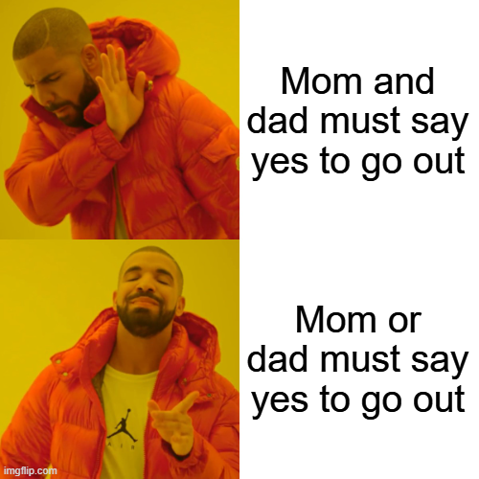

Example of Logical operator difference

What is the difference between Nested If and multiway if? How do we decide to choose one over the other when coding? *(As of 9/28/25, multiway if is discussed in M02L07)*

1. What are the logical operators discussed in this lecture? What does each do?
2. Consider the following:



* 1. What is the range of ints indicated here?
     1. Is 1 included? How about 100?
        1. If not, what can be changed to include these values?

1. Provide the steps needed to access the charAt() method
2. In Eclipse, briefly explore the following methods provided by the Character Class:

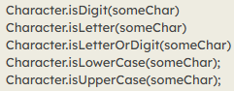



1. Switch Statements:
   1. What is it
   2. Can you provide a screenshot of the general format or an example of one in your technical document?
   3. What kind of values can I use in my switch expression?
   4. 
   5. How do I decide between using a switch versus an if statement?
2. How does the method next(), provided by the Scanner class, work?
3. Retry labs provided in this lecture